Full Stack Development with MERN
Project Documentation format
1. Introduction
- Project Title: Auto Ticket Classification using Flow Designer (Team ID: SWTID-2026-3677)
- Team Members:
  - Team Member 1 – ServiceNow instance setup, categories and assignment groups
  - Team Member 2 – Classification rules and keywords, flow trigger
  - Team Member 3 – Custom fields, reading the ticket description
  - Team Member 4 – Handling inconsistent descriptions, classification conditions, testing
  - Team Member 5 – Updating ticket fields, email notifications and dashboard
2. Project Overview
- Purpose: To automatically classify and route incoming service desk tickets in ServiceNow so that they reach the right support team quickly, without manual triage by agents. The goals are to reduce misrouted tickets and delays and to help meet SLAs.
- Features:
  - Flow triggered automatically when a new ticket is created.
  - Reads the ticket's short description and description and matches them against classification conditions and keywords.
  - Automatically sets the category, priority and assignment group.
  - Email notification to the requester and the agent, and a dashboard of classified tickets.
3. Architecture
- Frontend: No custom React frontend is used. Users raise tickets through the ServiceNow Service Portal, email or the incident form.
- Backend: No Node.js / Express.js server is used. The logic runs on the ServiceNow platform as a Flow Designer flow (trigger, conditions and update-record actions).
- Database: MongoDB is not used. Tickets are stored in the ServiceNow Incident table, and the flow reads and updates its fields (short description, description, category, priority, assignment group).
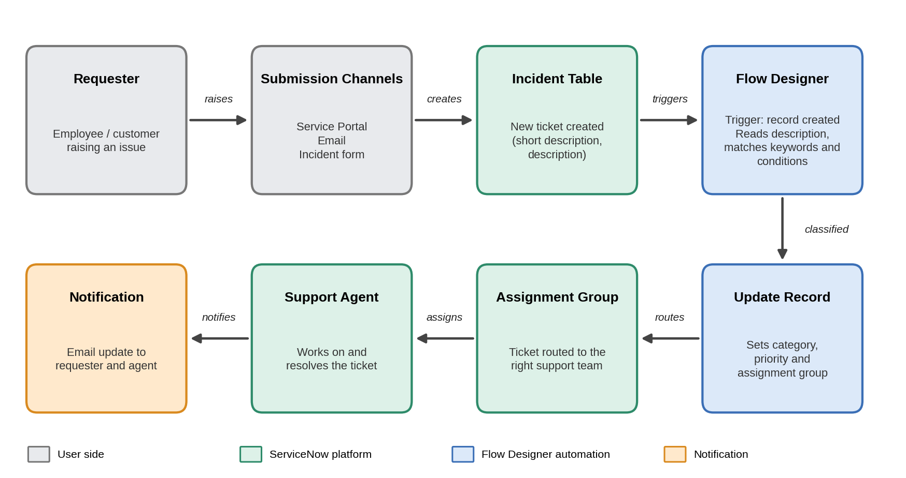
Figure 1: Architecture and data flow of the solution
4. Setup Instructions
- Prerequisites: A ServiceNow instance (for example a free Personal Developer Instance) with an administrator account and access to Flow Designer. Node.js and MongoDB are not required.
- Installation: Step-by-step guide to set up the solution:
- Request a ServiceNow Personal Developer Instance and log in as an administrator.
- Create the ticket categories and assignment groups.
- Add the custom fields for category and priority on the incident form, if they are not already present.
- Define the classification rules and keywords for each category.
- Open Flow Designer and build the flow (new-ticket trigger, classification conditions, update record), then activate it.
- Set up the email notifications and the dashboard.
5. Folder Structure
- Client: Not applicable. There is no React client folder; the user interface is the ServiceNow Service Portal and incident form.
- Server: Not applicable. There is no Node.js server folder. The solution is made of ServiceNow records: the Flow Designer flow, assignment groups, custom fields, notifications and dashboard, which are kept in the instance (and can be exported as an update set).
6. Running the Application
- There are no frontend or backend servers to start with npm. To run the solution:
  - Frontend: Log in to the ServiceNow instance and open the Service Portal or the incident form to raise a ticket.
  - Backend: Make sure the flow is activated in Flow Designer. It runs automatically each time a new ticket is created.
7. API Documentation
- No custom endpoints were developed, because the logic runs inside the ServiceNow platform.
- Tickets can also be created through ServiceNow's standard Table API, which triggers the same flow:
  - Method and endpoint: POST /api/now/table/incident
  - Parameters (request body): short_description, description
  - Example response (simplified):
{ "result": { "number": "INC0010001",
"short_description": "Cannot connect to VPN",
"category": "Network", "priority": "2",
"assignment_group": "Network Support" } }
8. Authentication
- Authentication and authorization use ServiceNow's built-in features. Users log in with their ServiceNow credentials and work within a session.
- Access is controlled by user roles and access control rules, for example administrators build and manage the flow, and support agents work on the tickets routed to their group. No separate token or custom login system was built.
9. User Interface
- Screenshots of the user interface, to be inserted here:
[Screenshot: Service Portal / incident form]
[Screenshot: ticket list showing automatically assigned category, priority and assignment group]
[Screenshot: dashboard of classified tickets]
10. Testing
- Testing was done manually. The team created sample tickets with different descriptions and checked that the flow ran and that each ticket received the expected category, priority and assignment group.
- The tools used were the ServiceNow incident form and Flow Designer's test and execution details to check each run of the flow.
11. Screenshots or Demo
[Screenshots of the flow in Flow Designer and of a classified ticket, or a link to a demo, to be inserted here]
12. Known Issues
- Classification depends on the conditions and keywords that were defined, so tickets with vague descriptions or no matching keyword may not be classified correctly and need manual review.
- New categories or keywords must be added to the flow by an administrator.
13. Future Enhancements
- Use machine-learning classification (for example ServiceNow Predictive Intelligence) alongside the keyword rules.
- Add more categories, ticket types (requests, changes) and departments.
- Add automatic SLA tracking and a Virtual Agent for ticket creation.

